**Pico CTF Challenge**

**Web Decode**

**(Pathway)**

**Challenge 1 : Web Decode**

**Category :** Web Exploitation

**Difficulty :**  Easy

**Description :** Do you know how to use the web inspector? Start searching here to find the flag

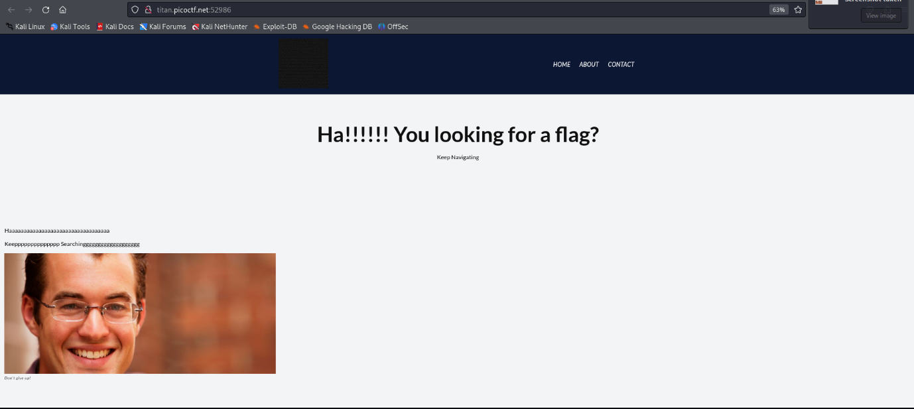Step 1 : Analyse the web page

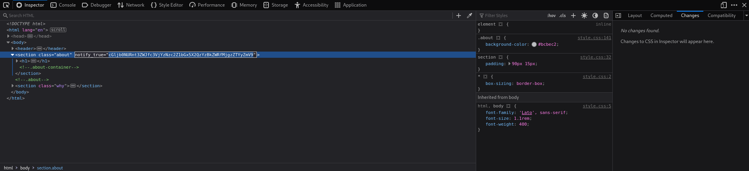Step 2 : Analyse the inspect of the web page

Here We can see a encoded , let’s decode using a online decryption tool

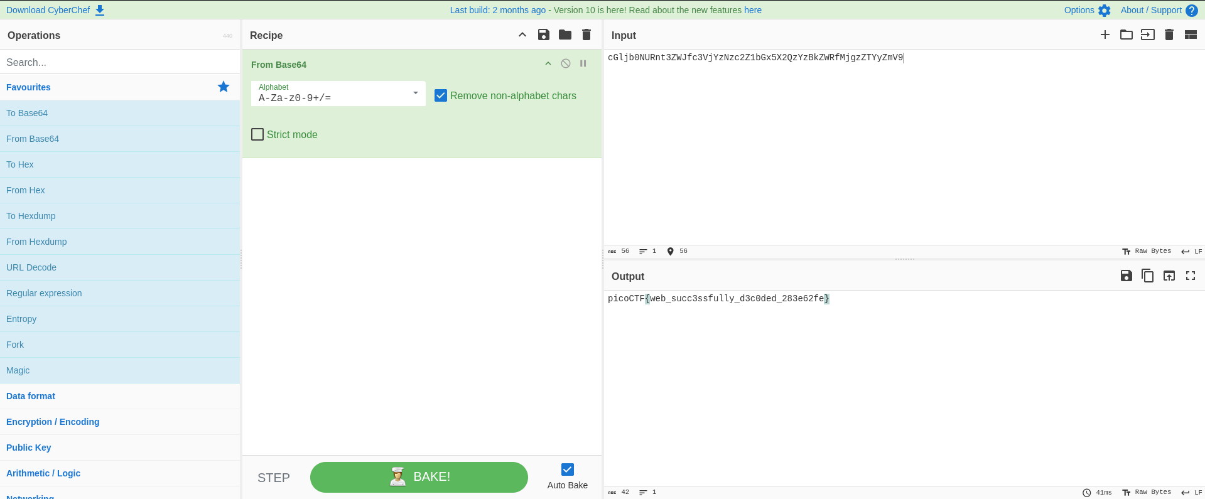

Here is the key : picoCTF{web_succ3ssfully_d3c0ded_283e62fe}